**Introduction**

This is the README on how to load data into Oracle tables and run Infoworks data ingestion for the tables.

**Prerequisites:**

* Install SQLDeveloper or other Oracle clients that can talk to Oracle server
* Install Infoworks product

**Steps to load data in Oralce and run cdc & merge in Infoworks UI:**

1. Run java program (Main) to generate a csv file

2. Create a table in Oracle

3. Use SQL Developer and go to the created table.

4. Right click on the table and choose "Import Data...."

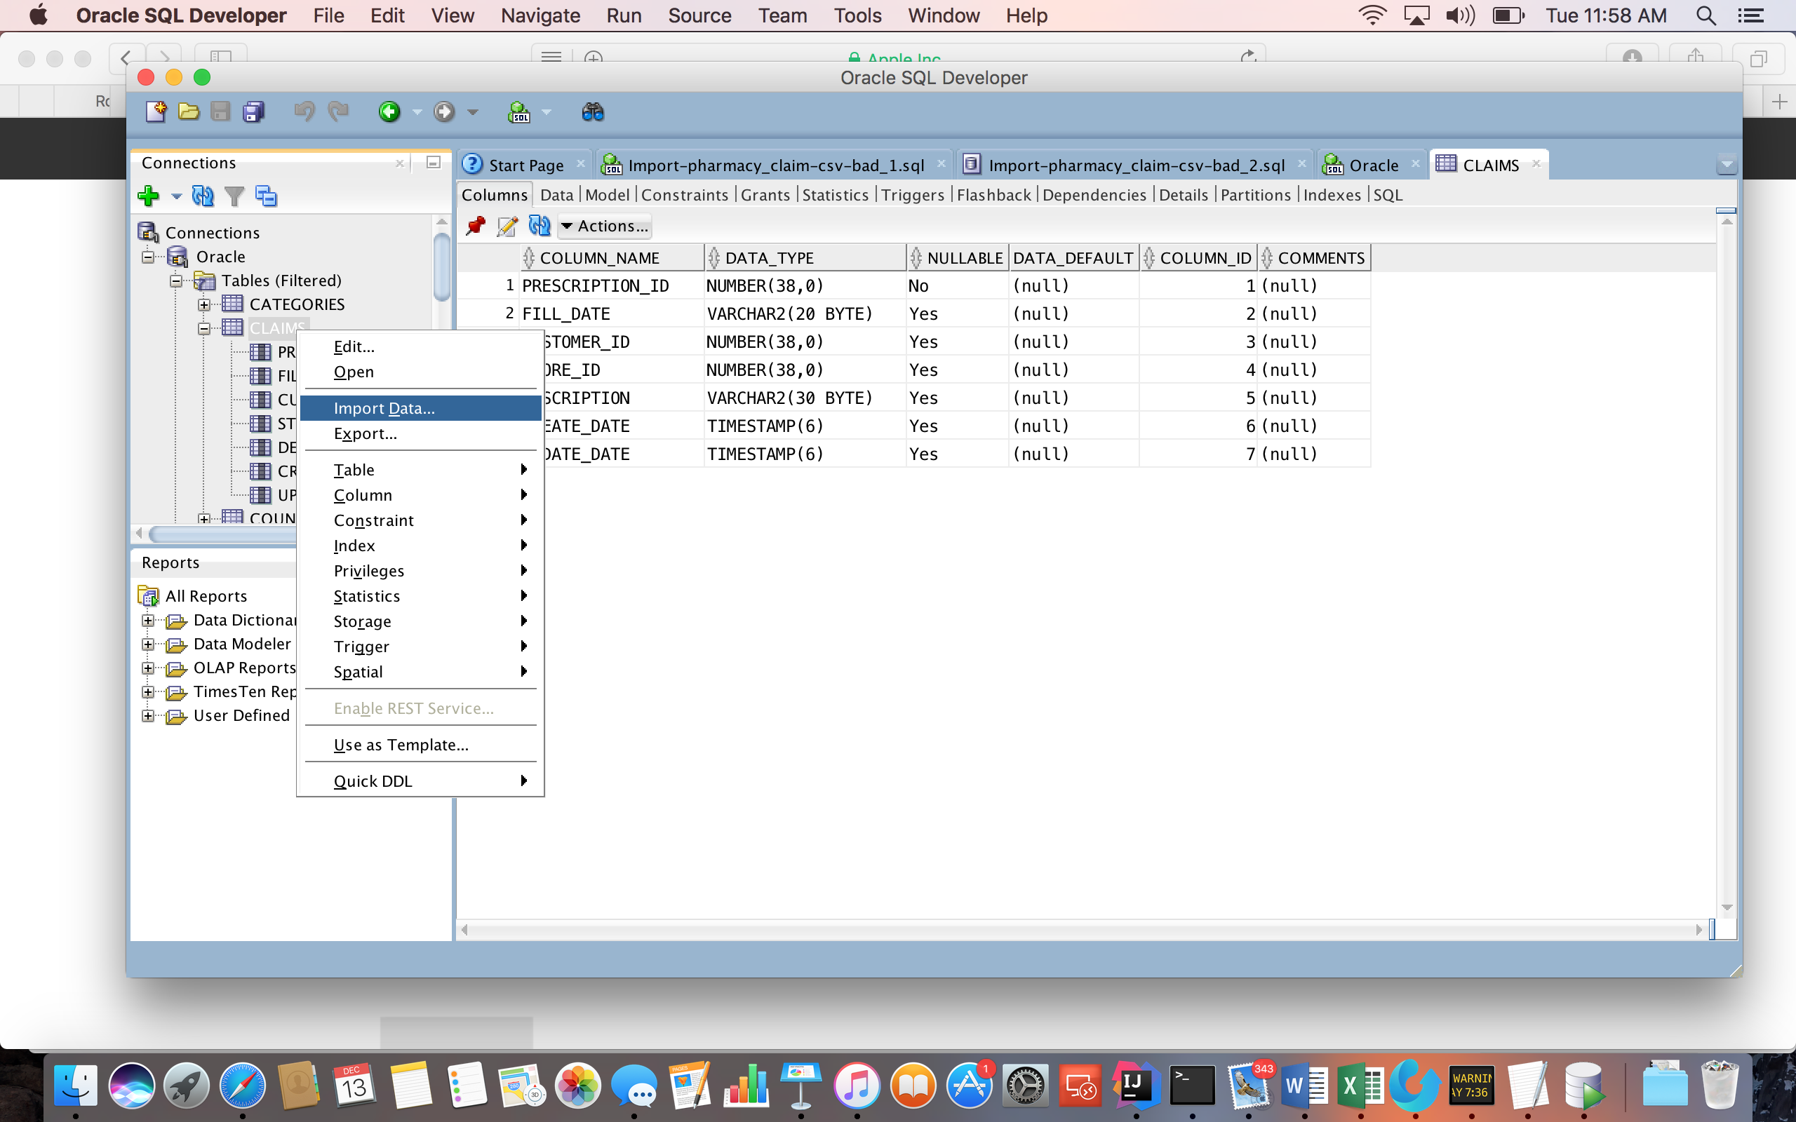

5. Follow the instructions on the UI to load the csv file and import the data.

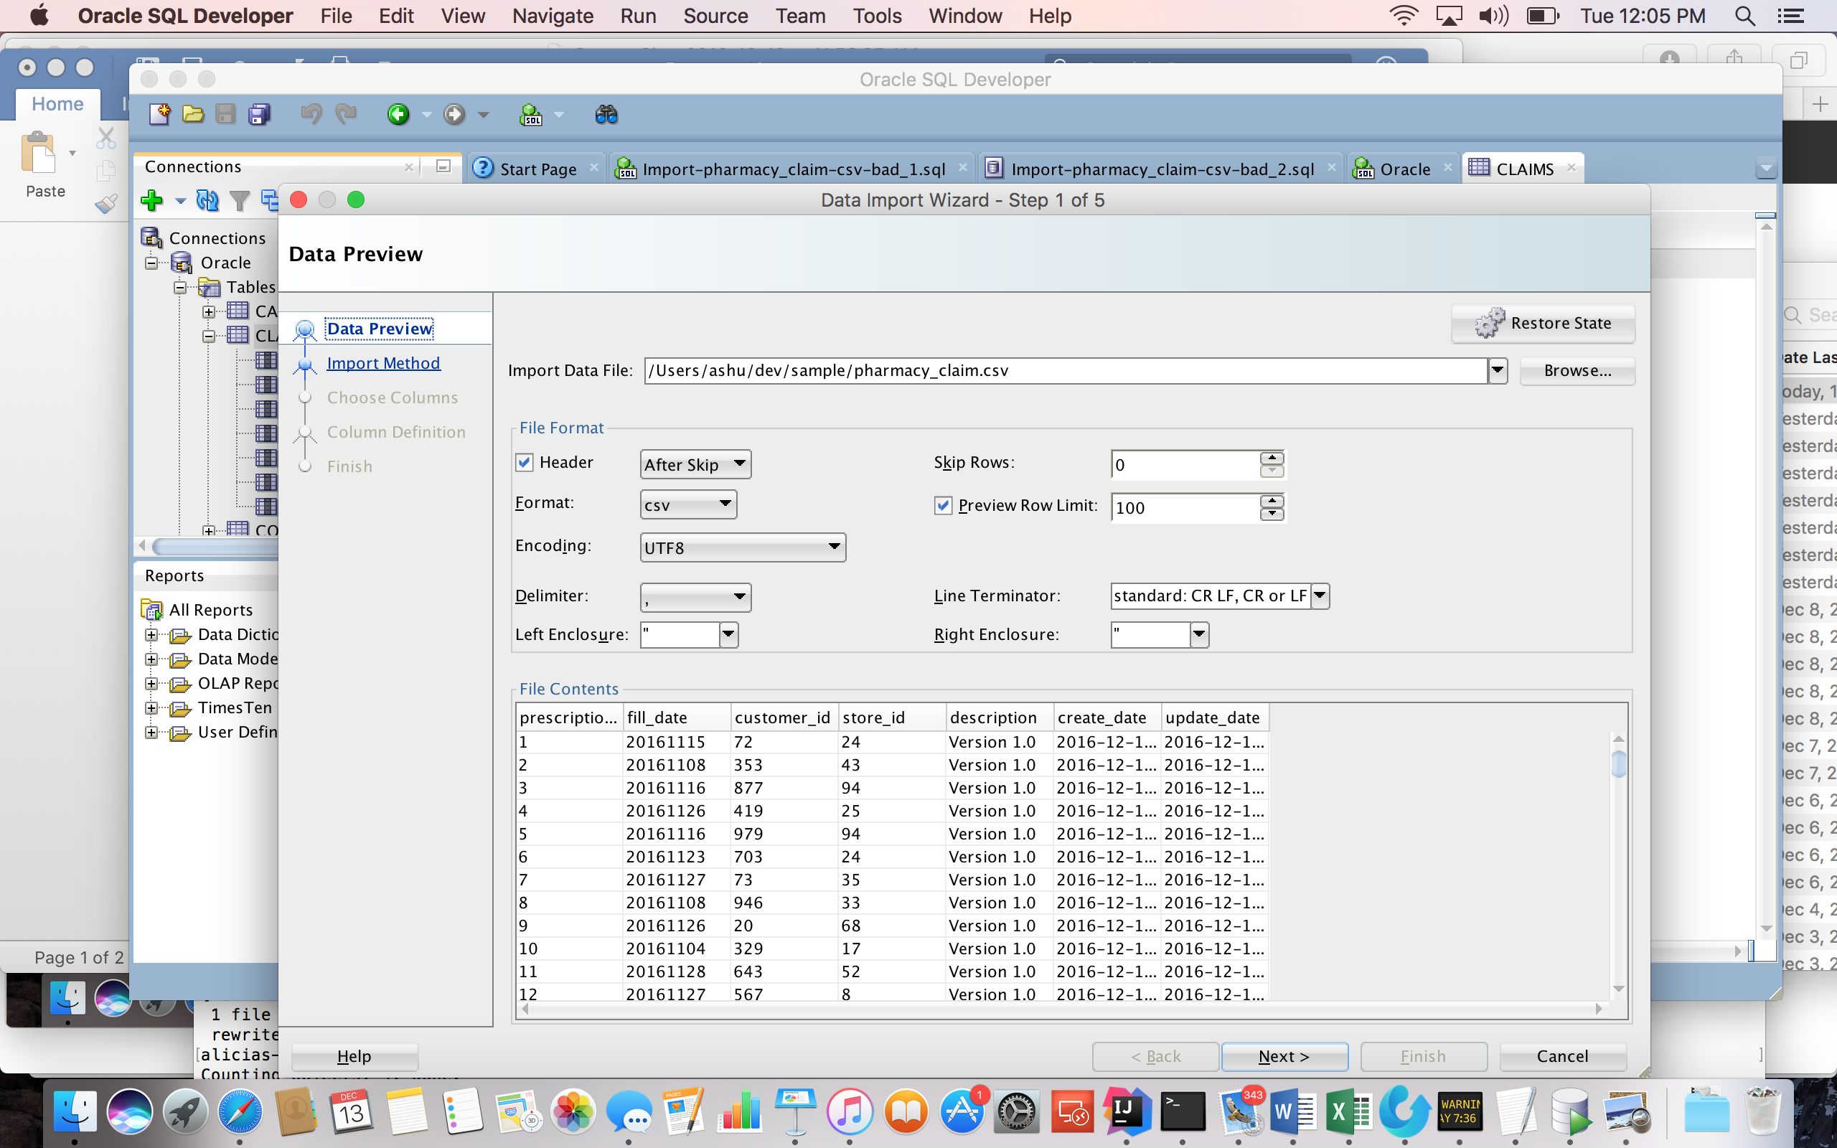

6. Create a source and a table group in Infoworks UI

7. Ingest the data into the created table group using Infoworks UI

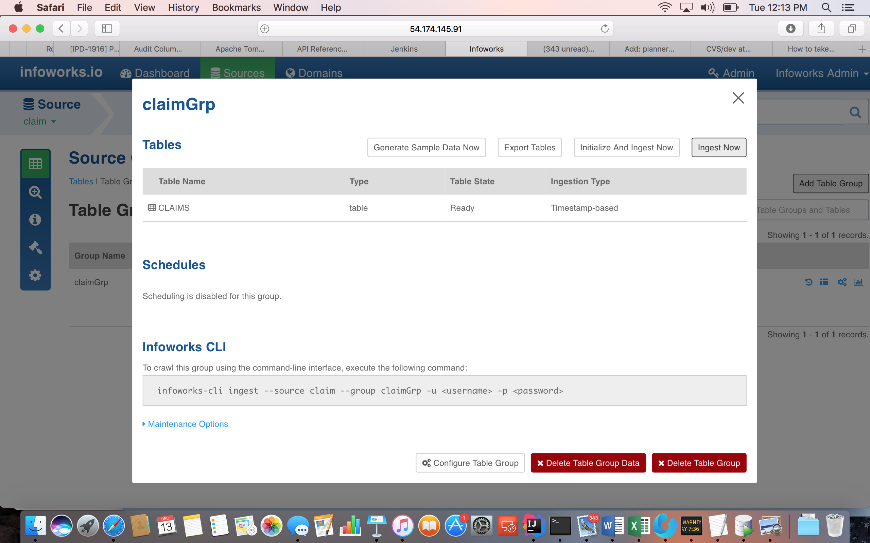

8. Run update statements or script in Oracle to update the table. A sample PL-SQL script:

declare

  prescrip_id number(20);

begin

  FOR i IN 1..1000 LOOP

    prescrip_id := dbms_random.value(1, 100000);

    update PHARMACY_CLAIM set description='Version 2.0', update_date=SYSTIMESTAMP where prescription_id=prescrip_id;

  END LOOP;

  commit;

end;

9. Run CDC from Infoworks UI

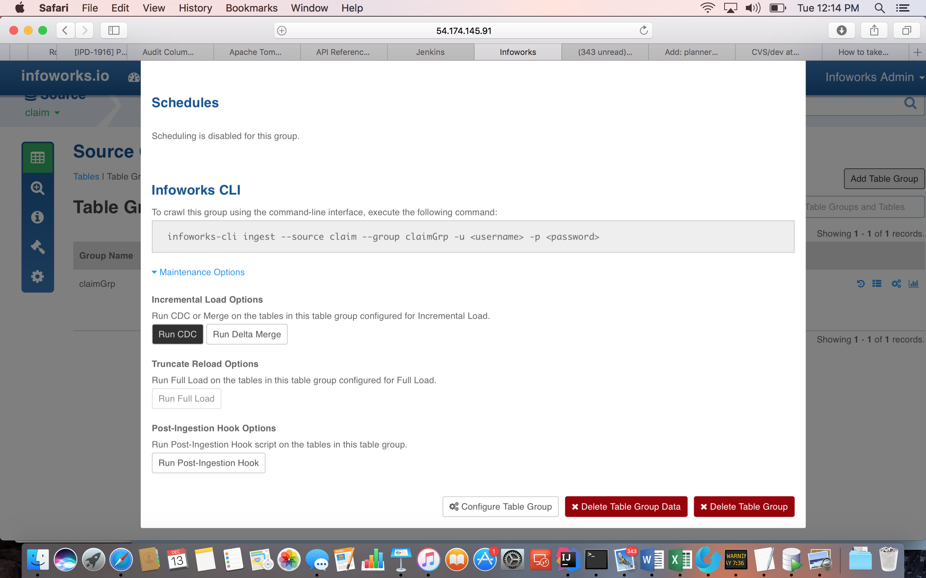

10. Run Merge from Infoworks UI

